Food Recipes Management System

Software Requirement Specification
Version 1.0

Prepared by: Ahad Al-jabri
Mayar Al-khalili
3\5\2026

Table of content

1. Introduction 3
1.1 Purpose 3
1.2 Scope 3
1.3 Overview 3
2. General Description 3
2.1 Users 3
2.2 Objectives 3
3. Data Requirements 3
4. Functional Requirements 3
5. Non-Functional Requirements 4
6. Tools & Technologies 4
7. Expected Outputs (Include Prototype) 4
8. Constraints 4
9. Project Timeline (Use clickup/ Notion/ etc) 5
10. Financial Requirements 5
10.1 Cost Breakdown 5
10. 2 Payment Terms 5
11. Key Insights 5
12. Recommendations 5

1. Introduction

1.1 Purpose
The purpose of this project is to design and implement a Recipe Database that stores and manages information about recipes, ingredients, and cooking instructions. The system aims to provide an efficient way to organize and retrieve recipe data.

1.2 Scope

The project includes the following tasks:

Designing the logical structure of the database

Applying normalization techniques to eliminate data redundancy

Implementing the database using SQL

Supporting basic operations such as:

Inserting data

Updating data

Deleting data

Querying recipe data

1.3 Overview
The Recipe Database will consist of multiple related tables such as recipes, ingredients, and categories. Relationships between these tables will be defined using keys to ensure data integrity. The database will allow users to easily search for recipes, view ingredients, and manage recipe information in a structured and efficient way.

2. General Description

2.1 Users
- Chef
- Restaurant
- Nutrition
- Food Blogger

2.2 Objectives
- Organize and store recipe data efficiently
- Reduce data redundancy through normalization
- Ensure data accuracy and integrity
- Enable easy searching and retrieval of recipes
- Support efficient database management using SQL
3. Data Requirements
- Data should be stored in a structured database format
- Data may include tables such as recipes, ingredients, and categories
- Each table should contain relevant attributes (e.g., recipe name, ingredients, cooking time)
- Data must be:
  - Complete
  - Accurate
  - Consistent
4. Functional Requirements
The system should:
- Store and manage recipe data in a database
- Allow adding, viewing, updating, and deleting recipes (CRUD operations)
- Store related information such as ingredients and categories
- Support searching recipes by name or ingredients
- Ensure data integrity using keys and relationships
- Retrieve data efficiently using SQL queries

5. Non-Functional Requirements
- The database must ensure data accuracy and consistency
- Queries should execute efficiently
- The system design should be simple and well-structured
- Data should be easy to access for different types of users
- The database should be maintainable and scalable

6. Tools & Technologies
- Database Language: SQL
Database Management System (DBMS):
- MySQL
Tools:
- MySQL Workbench
- Draw.io (for ER diagram design)
- claude

7. Expected Outputs (Include Prototype)
- Normalized database schema (1NF, 2NF, 3NF)
- ER Diagram showing relationships between tables
- SQL scripts for:
  - Table creation
  - Data insertion
  - Queries
- Sample outputs:
  - List of recipes and categories
  - Ingredients used in each recipe
  - Nutrition analysis for recipes
  - Meal and recipe relationships
Prototype:
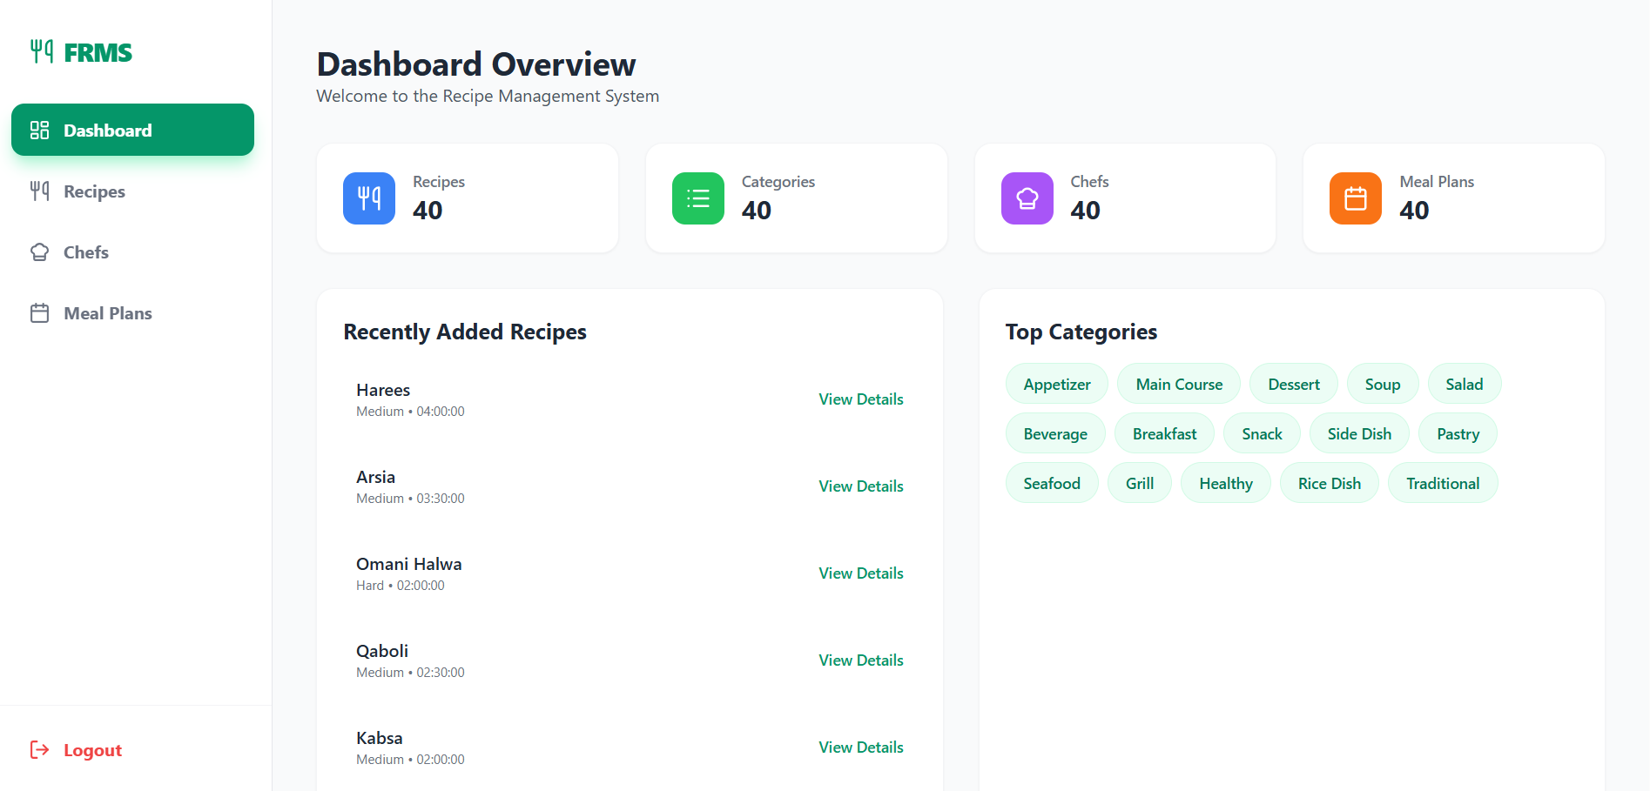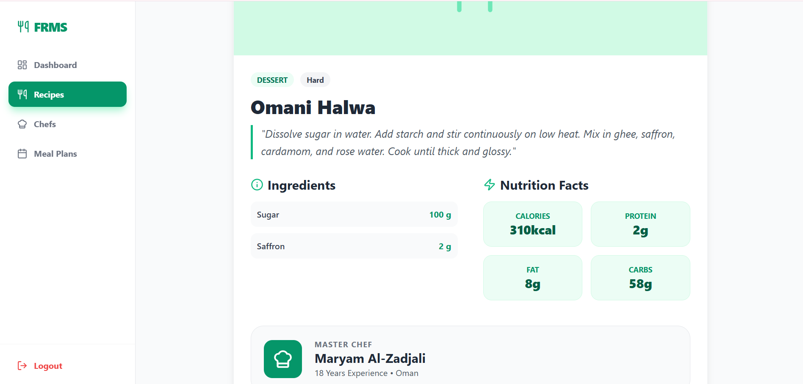

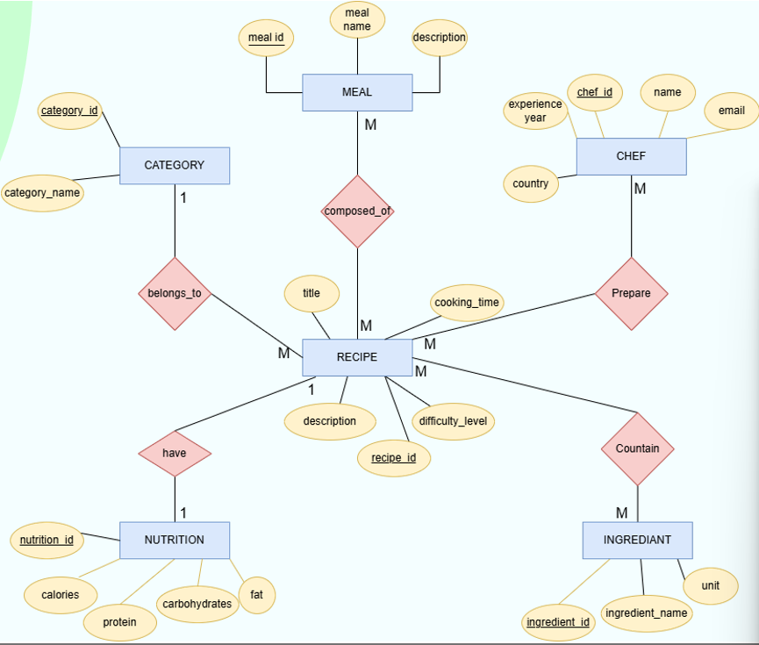
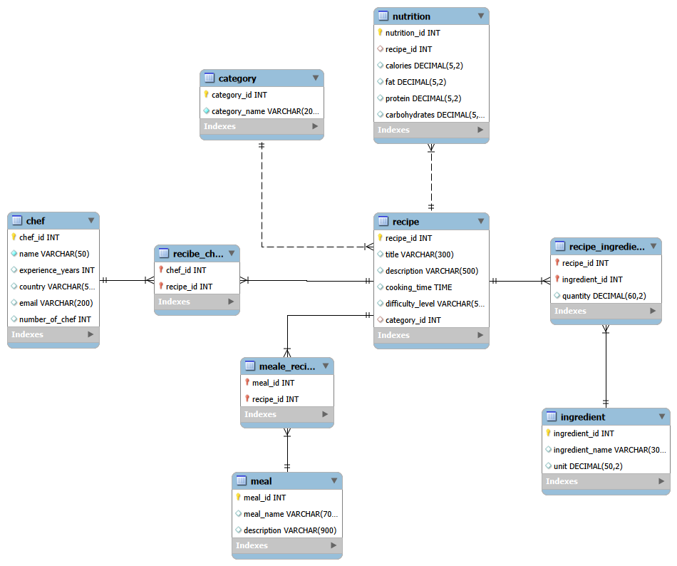

8. Constraints
- Limited project time
- The database may not include all types of recipes and ingredients.
- The system focuses only on database management and not online food ordering or customer interaction

9. Project Timeline :
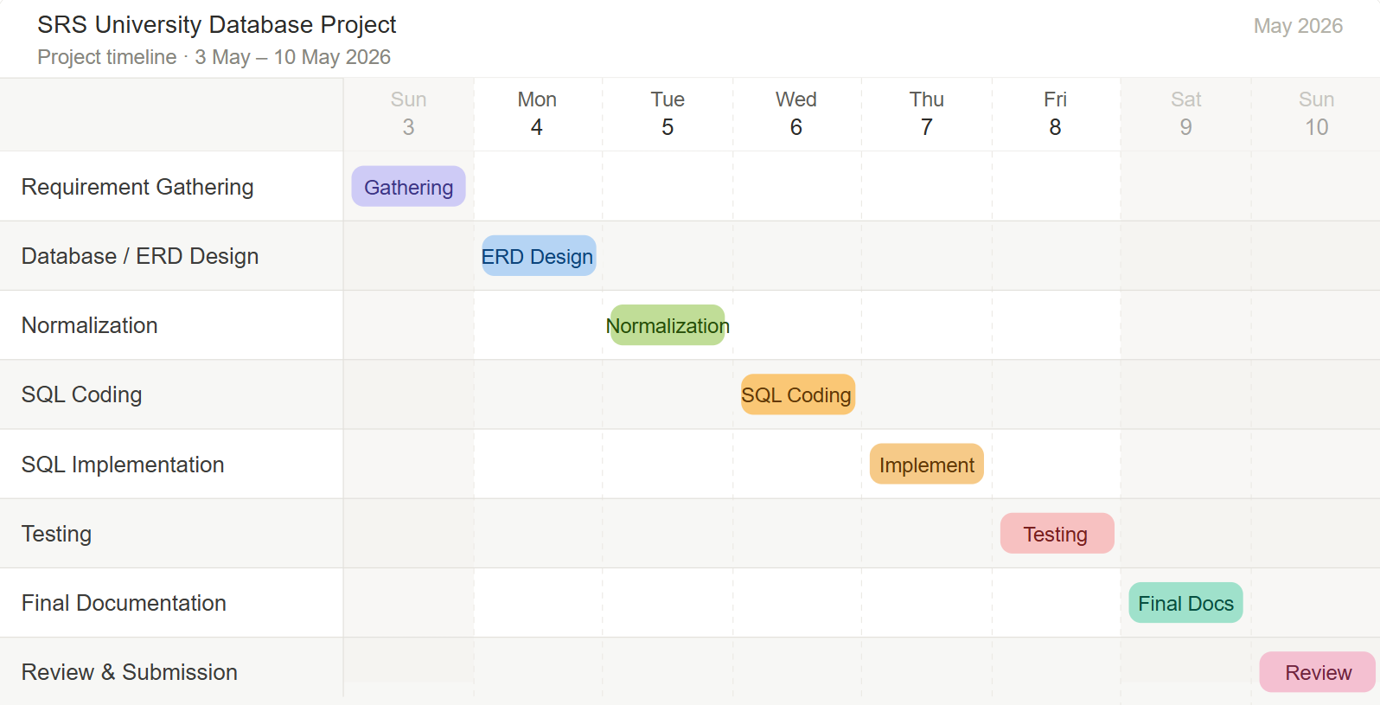

10. Financial Requirements

10.1 Cost Breakdown
Item | Description | Cost (OMR)
Data Preparation | Collecting and organizing recipe data | 50
Database Design | Creating tables, relationships, and schema | 70
Testing & Validation | Ensuring data integrity and query accuracy | 30
Deployment | Setting up and delivering the database | 20
Total |  | 170 OMR

10. 2 Payment Terms
Explain how payment will be done:
- 50% upfront
- 50% after completion

11. Key Insights
- A well-designed database improves the organization and retrieval of recipe data.
- Structuring data into tables (recipes, ingredients, instructions) reduces redundancy and ensures consistency.
- Using relationships to make the system more efficient.
- SQL queries enable fast searching, filtering, and management of recipes.

12. Recommendations
- Add more recipes and ingredients for better analysis
- Include recipe ratings and customer feedback in future versions
- Add advanced search and filtering features

